# Tasks in Service Desk looks like below.

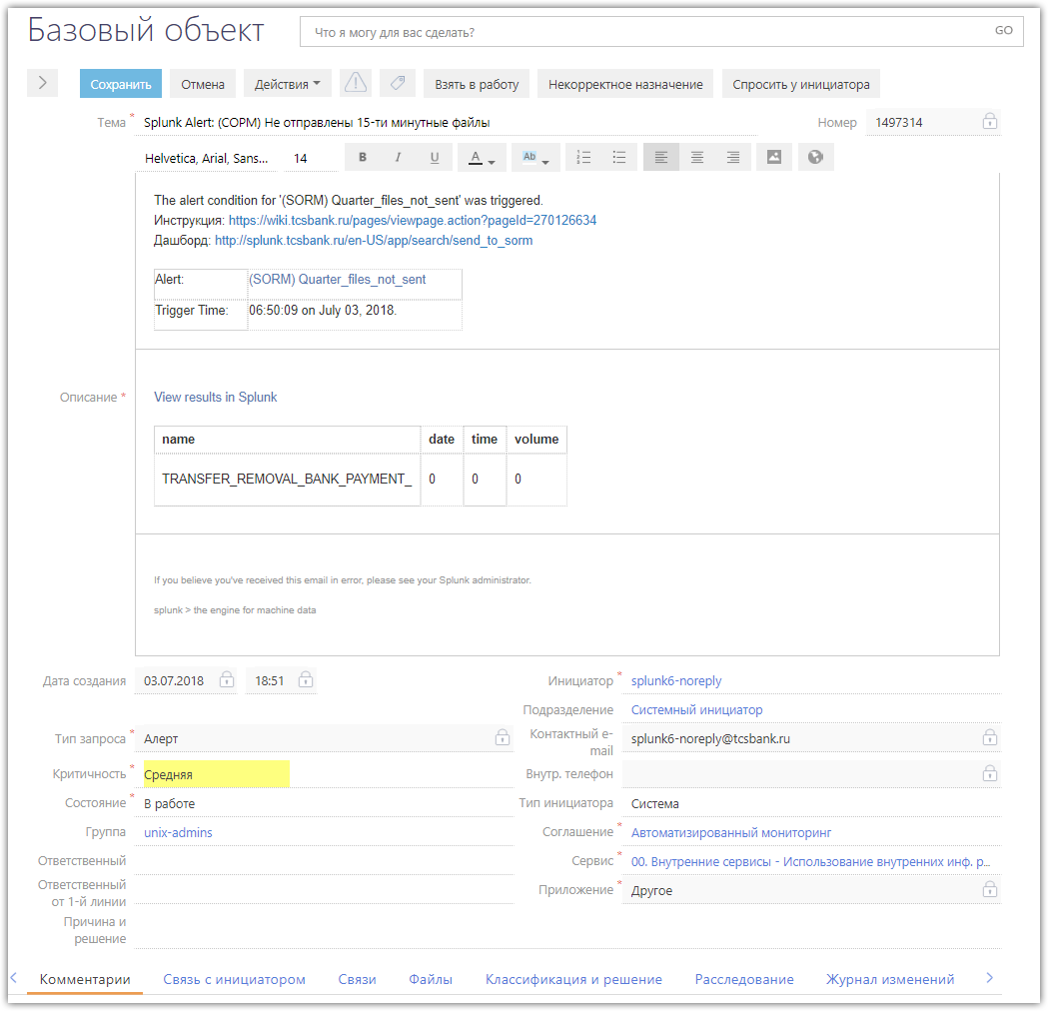

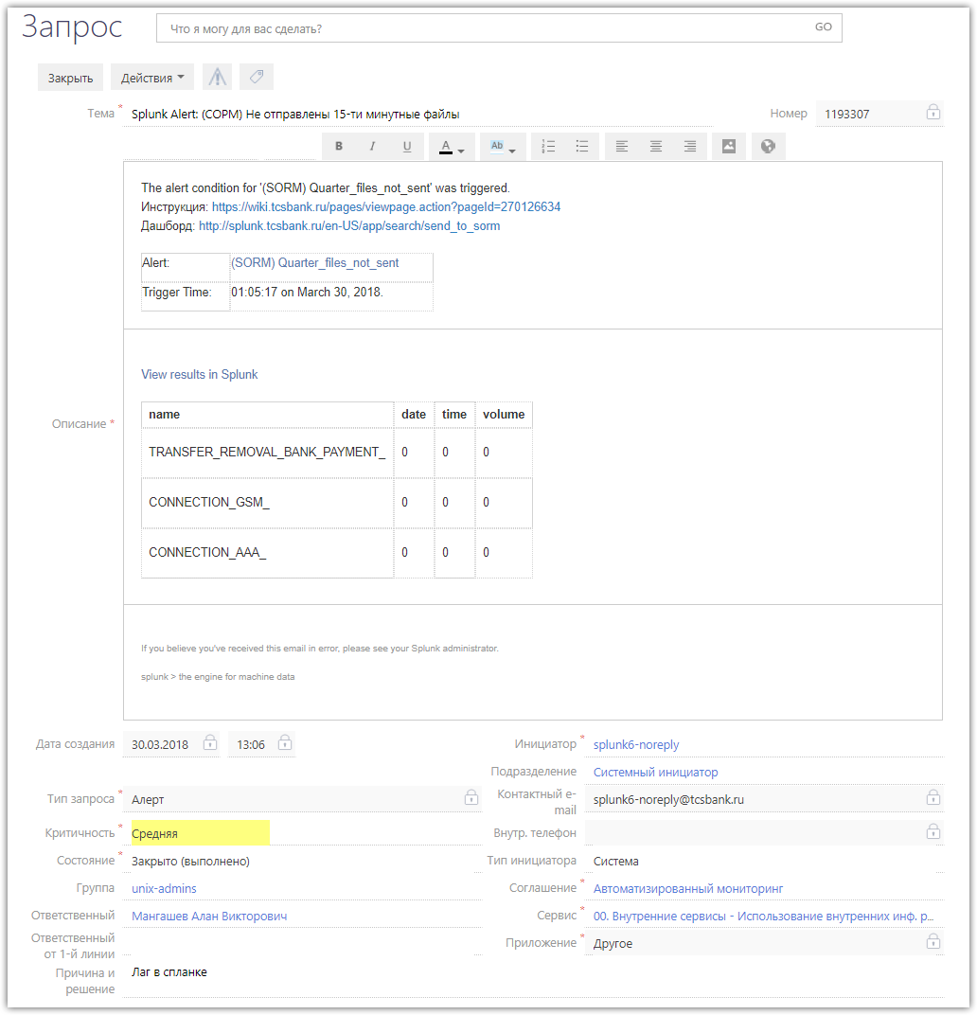
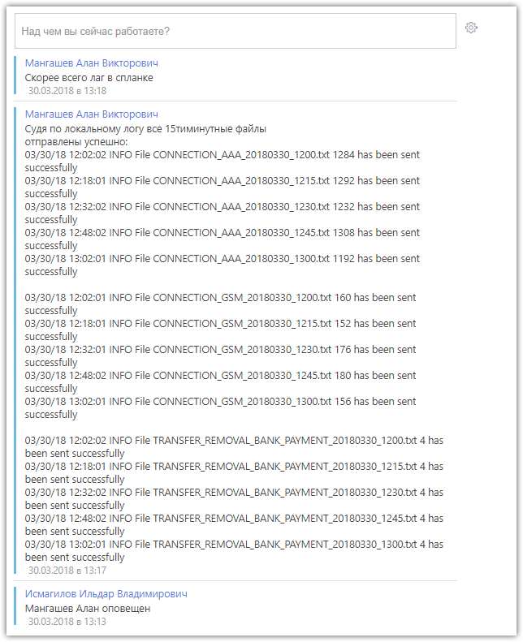

#
# Here is how to see: did files transfered successfully. And what files (it names) and in what time.
#
[root@ds-mvno-sorm-ftp01 ~]# grep -e "^07/03/18 19:" /opt/sorm3-logs/ftp-sorm3.log
07/03/18 19:02:01 INFO File CONNECTION_GSM_20180703_1900.txt 836 has been sent successfully
07/03/18 19:02:01 INFO File TRANSFER_REMOVAL_BANK_PAYMENT_20180703_1900.txt 4 has been sent successfully
07/03/18 19:03:01 INFO File CONNECTION_AAA_20180703_1900.txt 6912 has been sent successfully
07/03/18 19:18:01 INFO File CONNECTION_GSM_20180703_1915.txt 688 has been sent successfully
07/03/18 19:18:02 INFO File TRANSFER_REMOVAL_BANK_PAYMENT_20180703_1915.txt 4 has been sent successfully
07/03/18 19:19:01 INFO File CONNECTION_AAA_20180703_1915.txt 7020 has been sent successfully
07/03/18 19:32:02 INFO File CONNECTION_GSM_20180703_1930.txt 728 has been sent successfully
07/03/18 19:32:02 INFO File TRANSFER_REMOVAL_BANK_PAYMENT_20180703_1930.txt 4 has been sent successfully
07/03/18 19:33:01 INFO File CONNECTION_AAA_20180703_1930.txt 5900 has been sent successfully
[root@ds-mvno-sorm-ftp01 ~]#

#
# As I see it works as a cron task.
#
[root@ds-mvno-sorm-ftp01 ~]# cat /var/spool/cron/root
# Convert files and move them to upload
* * * * * /opt/sorm3-converter.sh

# Send file to sorm3 ftp
* * * * * /opt/sorm3-ftp_v3.sh

# Compress sent files
25 2 * * * /opt/sorm3-compress.sh

# Rotate log
00 0 * * * /sbin/logrotate /opt/ftp-sorm3
[root@ds-mvno-sorm-ftp01 ~]#

#
# Info about log files can be found here.
#
[root@ds-mvno-sorm-ftp01 ~]# cat /opt/ftp-sorm3
/opt/sorm3-logs/ftp-sorm3.log {
dateext
missingok
compress
daily
rotate 60
create 0664 root root
}
[root@ds-mvno-sorm-ftp01 ~]#

https://wiki.tcsbank.ru/pages/viewpage.action?pageId=270126634

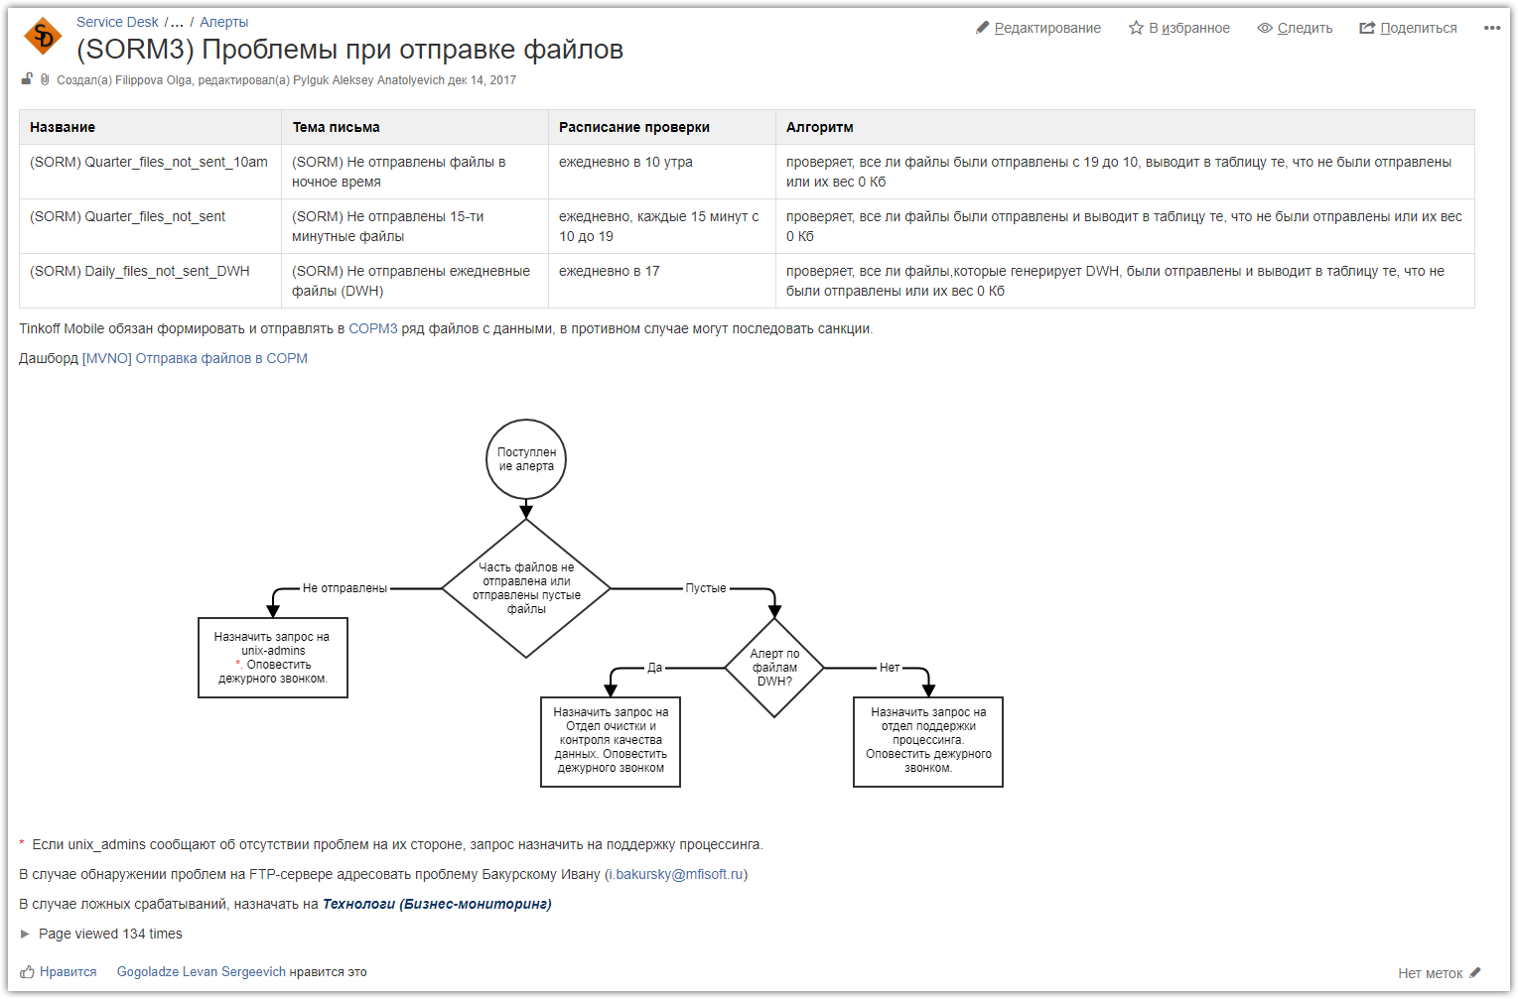

#
# The server exists in nagios. And there is a test for ftp port access.
#
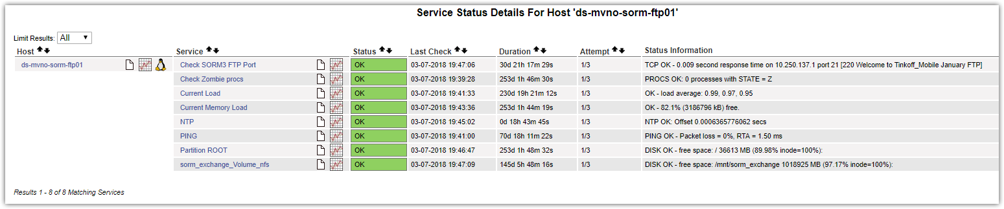

#
# 20190207
# If required resend file again.
#

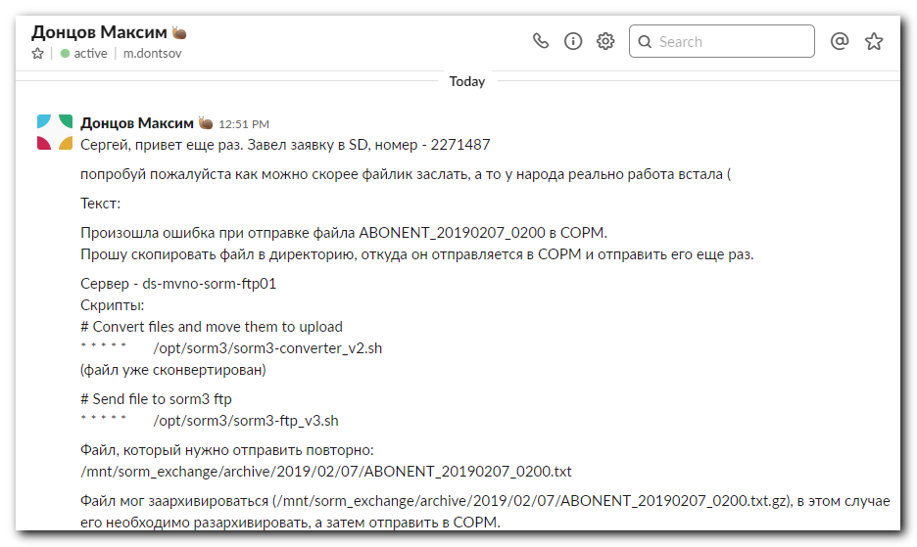

# Переместить файл в каталог из которого отправляются файлы.
[root@ds-mvno-sorm-ftp01 ~]# mv /mnt/sorm_exchange/archive/2019/02/07/ABONENT_20190207_0200.txt /mnt/sorm_exchange/upload/

# Через минуту, другую проверить журнал событий об отправки файлов.
# Должна появиться запись с текущим временем о том, что файл отправлен.
[root@ds-mvno-sorm-ftp01 ~]# grep -e "ABONENT_20190207_0200.txt" /opt/sorm3-logs/ftp-sorm3.log
02/07/19 07:53:01 INFO File ABONENT_20190207_0200.txt 79124 has been sent successfully
02/07/19 14:12:02 INFO File ABONENT_20190207_0200.txt 104104 has been sent successfully
[root@ds-mvno-sorm-ftp01 ~]#

